Green & White News
Turner County Extension Office 297-3112 turner.county@sdstate.edu September 2023

What a whirlwind few months it has been for the Turner County 4-H program! I am sure many of you are feeling the same way.
We want to thank everyone who has been part of this program and has helped in so many ways. From leading workshops, being a club leader, active parents, helping on committees, working the 4-H lunch stand, taking kids to camps or shooting sports practice or hooked up the trailer every weekend to head to a 4-H rodeo: thank you for making time for your kids to learn and grow! We couldn’t do it without you and want you all to know how much you are appreciated!

~Special Announcement~
As of August 2023, Kristen Wilke has joined the Turner County Extension office team! She comes on board as the new Turner County 4-H Program Assistant to take over Chris Wirt’s position.

“Greetings Turner County 4-H Members! I am beyond excited to start this new chapter with you! It has been my pleasure to meet so many new faces over the last couple weeks and hope to meet more families soon. To give a brief introduction of myself, I grew up in a farming family in Jerauld County where we were involved in various 4-H activities. My favorite was participating in our local 4-H horse club, and I am still passionate about horses today. I run my own equine massage business and created a program for learning it either online or hands-on. I have students from all over the United States and it’s incredible to reach so many horses through the work of my students. I attended school for Early Childhood Education and have worked with kids of various ages since. It’s truly a blessing to find a career that encompasses both agriculture and youth. Chris is going to be missed greatly and cannot ever be ‘replaced’. Please have patience and understanding through the many transitions that will take place over the weeks to come. I look forward to working alongside you…Thank you!” -Kristen Wilke

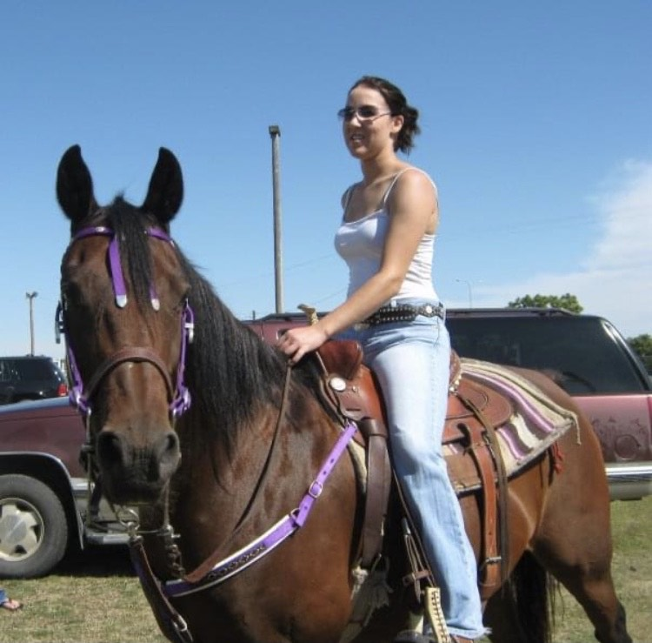

4-H Record Books Due
The horse shows, fairs and other 4-H activities are over, and it’s time to start working on your 4-H record books. 4-H members are not required to keep a record book but are highly encouraged to do so.
It is a great way to keep track of the activities and accomplishments you have participated in over the years. It also makes it easier having everything located in one place when it’s time to complete scholarship applications..

October 16th is the tentative date books will need to be turned in by…watch for the specific date in your email and October newsletter. The Turner County 4-H Leaders give $10 to each 4-H member that turns in a completed book, and an additional $10 if they attended a state activity such as state shooting sports match, State 4-H horse Show, State Fair or state judging contest.
There are two options for your record book:
- A written record book: you write in your information for the year.
- A fillable form that can kept on your computer from year to year. The form is attached to this email. Save to your computer/laptop under a different name such as ‘your name 4-H Record Book’ and you can go back in and add to it.

There are five parts to your completed record book. They are: Annual Report, Cumulative Reports,
4-H Story, pictures and news clippings. Examples are listed below:

Annual report: This report contains the “data” for you, your club, meetings as well as your personal and club goals.

Cumulative Reports: Please note that no FFA information should be included in these reports EXCEPT Community Service and Other Activities Report #7.

Leadership: Did you hold an office in your club or were on a committee? Did you participate in iLEAD, sing the Star Spangled Banner or lead the flag pledges at your club meeting? Many of you helped in the 4-H lunch stand. That is an example of leadership; you helped others to accomplish a big task. Think outside the box for this report.
Public Presentations: If you did a public presentation at the club or county level, this report is where to list the information. Horse project members should all have a talk listed, as that is part of your horse safety requirements. No FFA or breed association talks should be listed here unless you switched to be a 4-H talk.

Judging: Livestock judging, horse judging, Consumer Decision Making, and horticulture judging can all be listed here. No FFA judging should be listed.

Other Youth-in-Action Activities: Showmanship, Fashion Revue, Shooting Sports, Special Foods, Quiz Bowl, 4-H Camp, TLC, CWF.

Project Exhibits: You can list each project on a separate line along with the placing, or list them by project area. Examples are: ‘2022 Foods and Nutrition Drop Cookies County/State CP1’ OR ‘2022 Food and Nutrition – 3 County/State CP1/CB2’. C refers to county and S is State. P, B, R W refer to ribbon placing and then the number that corresponds.
Those of you that do the horse show can do each event individually or by showmanship, equitation, performance, and timed events.

Other Awards, Honors, Recognition: County Project Pins, 4-H Record Book Dollars, top judging awards, All Around Horse Awards, trips, scholarships, county and state fair awards, Judge’s Choice or Outstanding Exhibit rosettes can all be listed here.

Community Service and Other Activities: This can be school related, 4-H, FFA, church and community activities.

*Note: As you fill up these pages, they can go behind the current year’s record book*

4-H Story: This is our favorite part of the record book! Write about what you did over the year, good things and things that didn’t turn out the way you planned. Did you reach your goals? What do you want to do next year? What was your favorite part of 4-H? This can be typed or hand written. If a parent types the story for their child, it must be how the child says it.

Pictures: We like to see pictures of activities you have done over the past year. These should be 4-H related. You are welcome to put captions by the picture if you would like.

News Clippings: Club meeting minutes that have been in the paper, along with county and state events should be in the paper. You do not have to put all the results in…you can cut out the project areas you were involved in. Be sure to highlight your name.

Livestock Financial Record: This is for beef, sheep, dairy, swine, and goats. Put the report in after the cumulative report and before the pictures. Forms are available at the Extension office.

The last page of the record book should go before the story, pictures, and news clippings. BE SURE BOTH A PARENT AND 4-H MEMBER SIGNS THE PAGE!

If you don’t have anything to put down under a report, write ‘2023 N/A’. We do have 4-H Record Book Covers available at the Extension Office for $3 each if you need one. If you would like some help, please contact the Extension Office.

You can find fillable and printable forms by visiting:
https://turner.sdcounties.org/extension-office.html

Horse Project Members
If you exhibited a horse at the County 4-H Horse Show and would like to be considered for the All Around 4-H Horse Award in your age division, you will need to complete a 4-H Record book. Results from the County 4-H Horse Show are taken into consideration for the award. If there is a tie, State
4-H Horse Show results will be included. Each age division has one award to be given out.

4-H Ambassadors
4-H Ambassadors are chosen from senior 4-H members who have completed a record book. Considerations include community service activities, leadership/activities on the county and state levels, and a completed record book.
County Project Awards
If you have been in 4-H for 3 years, participated in a project area for two years and have presented a county level talk or two club talks in that area, you can apply for a project pin.
Look over your record book to see if you have the proper documentation to apply for one of the many project awards that are available. You can only receive a project pin in the project area one time.
An award application will be included with the October Newsletter. If you don’t qualify for one this year, make it a goal of yours to complete the requirements in 2023-2024.
If you are at least 14 years old, you can also apply for the County 4-H Leadership, Citizenship or Key Award. Information is available from the office.

TLC, 4-H Camp and Livestock Judging Camp Scholarships
If you attended 4-H Camp, TLC or Livestock Judging Camp this summer, you still have the opportunity to apply for a Turner County 4-H Leaders Reimbursement Scholarship until the end of the year. Complete the form that is included with the newsletter, along with the appropriate paperwork, and return it to Dawn Leber. You can apply for up to two scholarships. They are $75 each.
You can also apply for the State 4-H Leaders Scholarship for the same events along with Performing Arts Camp. A scholarship is also available if you went on a national trip for 4-H Shootings Sports. You can also apply for a scholarship if you attended the National 4-H Events at Denver in 2022 for Fashion Revue and Consumer Decision Making. For 4-H camp, you need to do a presentation for one group (your 4-H club). For the TLC and Livestock Judging camp, you need to do a presentation for two different groups.
You can find the State 4-H Leaders Scholarship at: http://sd4hleaders.users.santel.net/doc/App-AmbassadorScholarship.pdf.
Both of these scholarships need to be at the appropriate people BEFORE the end of the year.

County Fair Awards
If you received an award at the county fair for Special Foods, Public Presentations, Fashion Revue, Horsemanship, Scholarships, livestock or other awards, you will be receiving a letter in the next couple of weeks that list the sponsor(s) of your awards. You will need to write them a thank you for being a 4-H sponsor. They appreciate hearing from you, and IT DOES make a difference the following year in whether a sponsor continues to write a check to sponsor 4-H awards.

Turner County Fair Premium Checks
The 4-H premium checks will be sent out as soon as our office receives them. Please keep an eye out for them in the mail.

4-H Livestock Premium Sale Checks
The 4-H Livestock Premium Sale checks will be mailed out soon as the invoiced bills are paid from different entities. You need to write a thank you to the purchaser of your premium when your check comes. The check comes from the Turner County 4-H Leaders.

Club Pictures
Thanks to those clubs that have sent in a club picture to the office this year. If you have one, we would appreciate it if you would send a digital copy to turner.county@sdstate.edu.

2024 Turner County Fair Dates
The 2024 Turner County Fair Dates are August 12-15. There were schools that started during the county fair, and if you want to get that changed, now is the time to start visiting with school board members. We can get you the information on how many 4-H members attend your school so you can figure out the percentage of kids that are affected.
We understand that sports are important, but for many of our kids, 4-H is their sport. Ask them to wait to start school so you can finish up your sport of 4-H. Talk to them about your responsibilities, whether it’s taking care of your animals or working in the 4-H lunch stand. Responsibility and community service are two talking points you can focus on. There is a time on each school board’s agenda that has an opportunity for public comment. Get on the schedule and have your whole club come if you can, to talk to the school board about changing the start date of school. You can also write a Letter to the Editor to your local newspaper.

New Year Begins October 1
The new 4-H year begins on October 1. That is the time to invite others to join and be an active part of your club and the 4-H program. There will be information included in the October newsletter on re-enrolling in 4-H.
We have said many times before that 4-H is a family activity. Work with your 4-H club leader to be a host for a meeting or put together an activity. Attend the meetings with your child/children so you know what is going on and expectations of being a member of your club.

National 4-H Week October 1-7
National 4-H Week is October 1-7th. Is there something your club could do to help celebrate the week or encourage others to join 4-H? Maybe there are 4-H sponsors in your community that you can do something for, such as baking some cookies. Talk to your school, church, or other entity about bringing in some of the exhibits you made for the fair to display. We also have picture boards that you could borrow to show others about some of the activities that have happened over the past year.
Let’s plan to wear a 4-H t-shirt to school on Wednesday, October 4 to show them the power of 4-H!
If you would like to have bookmarks made for a classroom or candy wrappers made for miniature candy bars, let the office know before 4-H Week so we can get them done for you.

October 4-H Leaders Meeting
In addition to election of the 4-H Executive Board and evaluating record books, other items will be discussed at the tentative date of October 16 4-H Leaders Meeting. Please plan to have at least one leader or parent present for the meeting. It will be held at the Courthouse Community Room at 7 p.m.

State 4-H Rodeo Participants
Turner County had 12 4-H members that qualified for the State 4-H Rodeo Finals in Pierre August 18-20. They had to place in the top 4 of a regional 4-H rodeo to qualify for the state finals.

Chase Fischer- Jr. Cattle Riding
Cayden Huls- Jr. Goat Tying, Jr. Breakaway, Jr. Flag Race
Payson Acheson- Jr. Cattle Riding

Beckett Hutcheson- Senior Boys Bull Riding

Kinzie Zimmerman- Jr. Girls Poles, Jr. Girls Barrels
Joslyn Dekneiker- Jr. Girls Poles
Kaylee Novak- Jr. Girls Poles, Jr. Girls Barrels
Addison Kastner- Jr. Girls Poles
Ayla Bartman- Jr. Girls Flag Race
Izabella Kastner- Jr. Girls Poles

Maddy Eldeen- Sr. Girls Poles
Maddy Boyd- Sr. Girls Poles

Payson Acheson- 4th Overall Jr. Boys Cattle Riding

(Apologies if we missed someone)

** If this belongs to you, please pick up at the Extension Office**
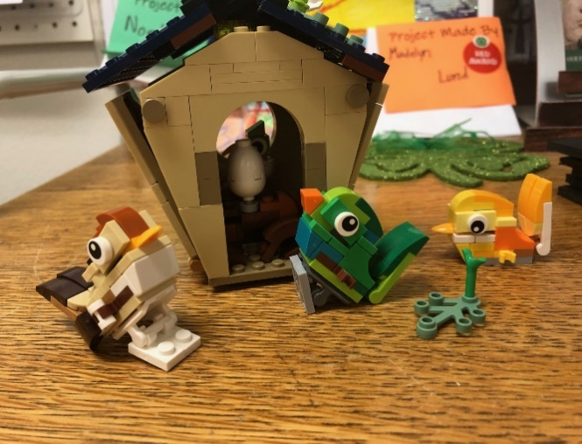

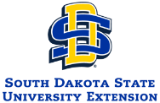
SDSU is an equal opportunity provider and employer in accordance with the nondiscrimination policies of South Dakota State University, the South Dakota Board of Regents and the United States Department of Agriculture.
Learn more at extension.sdstate.edu. ©2021, South Dakota Board of Regents.

